**Module 4 Assignment Base Queries (BQ)**

1. **BQ1**

SELECT W_JOB_F.Location_ID,Location_Name,W_SALES_CLASS_D.Sales_class_id,Sales_Class_Desc,Time_Year,Time_Month,Base_price,SUM(Quantity_Ordered) AS SUMQTY,SUM(Quantity_Ordered*Unit_Price) AS Job_Amount

FROM W_JOB_F,W_LOCATION_D,W_SALES_CLASS_D,W_TIME_D

WHERE W_JOB_F.Location_ID = W_LOCATION_D.Location_ID AND W_JOB_F.Sales_class_id = W_SALES_CLASS_D.Sales_class_id AND W_TIME_D.Time_id = W_JOB_F.Contract_date

GROUP BY W_JOB_F.Location_ID,Location_Name,W_SALES_CLASS_D.Sales_class_id,Sales_Class_Desc,Time_Year,Time_Month,Base_price;

Result: (1705 rows)

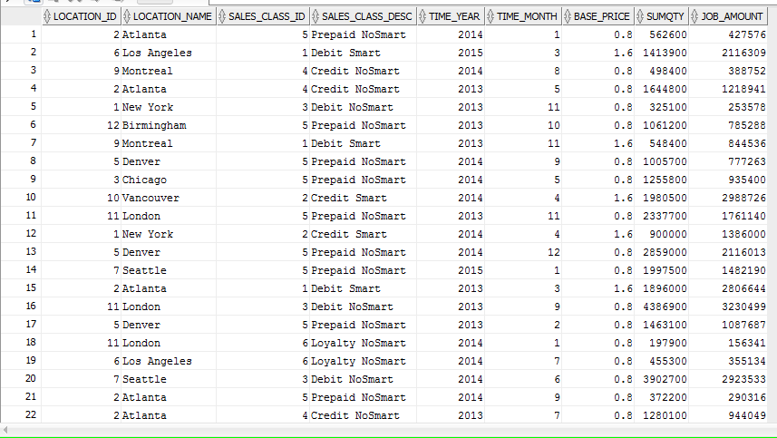

1. **BQ2**

SELECT W_JOB_F.JOB_ID,W_JOB_F.Location_ID,W_Location_D.Location_Name,Unit_Price,Quantity_Ordered,Time_Year,Time_Month,SUM(Invoice_Amount) AS SUMINVAMT,SUM(Invoice_Quantity) AS SUMINVQTY

FROM W_JOB_F,W_LOCATION_D,W_TIME_D,W_INVOICELINE_F,W_SUB_JOB_F,W_JOB_SHIPMENT_F

WHERE W_JOB_F.Location_ID = W_LOCATION_D.Location_ID AND W_TIME_D.Time_id = W_JOB_F.Contract_date

AND W_Job_Shipment_F.Invoice_Id = W_InvoiceLine_F.Invoice_Id AND W_JOB_F.Job_Id = W_SUB_JOB_F.Job_Id AND W_JOB_SHIPMENT_F.Sub_Job_Id = W_Sub_Job_F.Sub_Job_Id

GROUP BY W_JOB_F.JOB_ID,W_JOB_F.Location_ID,W_Location_D.Location_Name,Unit_Price,Quantity_Ordered,Time_Year,Time_Month;

CREATE VIEW BQ2 AS

SELECT W_JOB_F.JOB_ID,W_JOB_F.Location_ID,W_Location_D.Location_Name,Unit_Price,Quantity_Ordered,Time_Year,Time_Month,SUM(Invoice_Amount) AS SUMINVAMT,SUM(Invoice_Quantity) AS SUMINVQTY

FROM W_JOB_F,W_LOCATION_D,W_TIME_D,W_INVOICELINE_F,W_SUB_JOB_F,W_JOB_SHIPMENT_F

WHERE W_JOB_F.Location_ID = W_LOCATION_D.Location_ID AND W_TIME_D.Time_id = W_JOB_F.Contract_date

AND W_Job_Shipment_F.Invoice_Id = W_InvoiceLine_F.Invoice_Id AND W_JOB_F.Job_Id = W_SUB_JOB_F.Job_Id AND W_JOB_SHIPMENT_F.Sub_Job_Id = W_Sub_Job_F.Sub_Job_Id

GROUP BY W_JOB_F.JOB_ID,W_JOB_F.Location_ID,W_Location_D.Location_Name,Unit_Price,Quantity_Ordered,Time_Year,Time_Month;

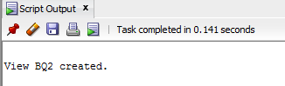 (2504 rows)

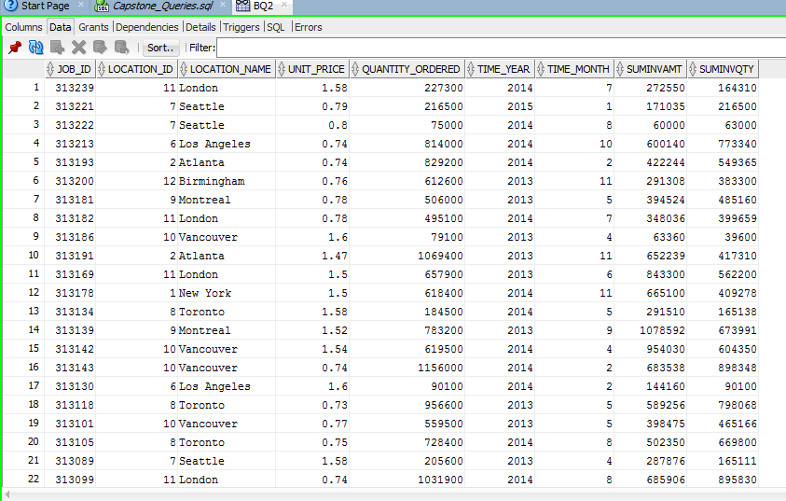

1. **BQ3**

CREATE VIEW BQ3 AS

SELECT JOB_ID,Location_ID,Location_Name,Time_Year,Time_Month,SUMLABOUR, SUMMATERIAL, SUMOVERHEAD,SUMMACHINE,SUMQTY,TOTALCOST,TOTALCOST/SUMQTY AS UNIT_PRICE

FROM (

SELECT W_SUB_JOB_F.JOB_ID,W_SUB_JOB_F.Location_ID,Location_Name,Time_Year,Time_Month,SUM(Cost_Labor) AS SUMLABOUR,SUM(Cost_Material) AS SUMMATERIAL,SUM(Cost_Overhead) AS SUMOVERHEAD,SUM(Machine_Hours*Rate_per_hour) AS SUMMACHINE,SUM(Quantity_produced) AS SUMQTY,

SUM(Cost_Labor+Cost_Material+Cost_Overhead+Machine_Hours*Rate_per_hour) AS TOTALCOST

FROM W_SUB_JOB_F,W_JOB_F,W_TIME_D,W_LOCATION_D,W_MACHINE_TYPE_D

WHERE W_SUB_JOB_F.Job_id = W_JOB_F.Job_id AND W_location_d.location_id = W_SUB_JOB_F.Location_id AND W_Time_D.Time_id = W_Job_F.Contract_Date AND

W_SUB_JOB_F.Machine_Type_id = W_Machine_Type_D.Machine_Type_ID

GROUP BY W_SUB_JOB_F.JOB_ID,W_SUB_JOB_F.Location_ID,Location_Name,Time_Year,Time_Month);

(2527 rows)

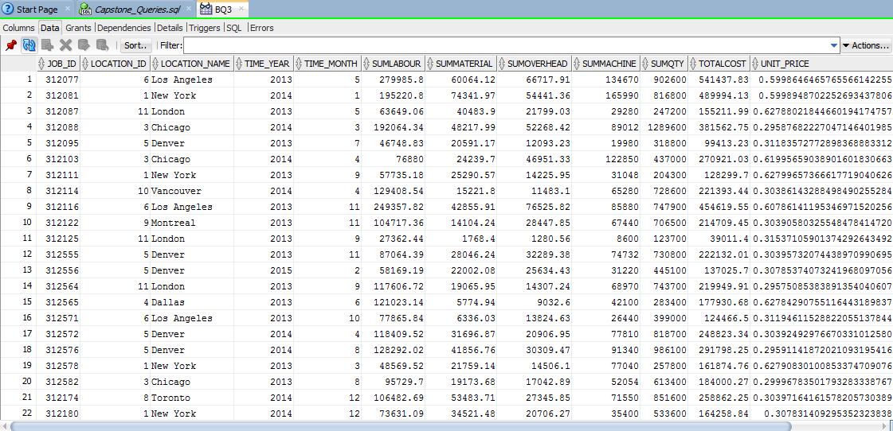

1. **BQ4**

SELECT W_InvoiceLine_F.Location_Id, Location_Name,W_InvoiceLine_F.Sales_Class_Id, Sales_Class_Desc,Time_Year, Time_Month,

SUM ( Quantity_shipped - Invoice_Quantity ) as QTYRETURNED,SUM ( (Quantity_shipped - Invoice_quantity) * (Invoice_amount/Invoice_quantity) ) AS SUMAMTRETURNED

FROM W_INVOICELINE_F,W_Location_D ,W_Sales_Class_D,W_TIME_D

WHERE quantity_shipped - invoice_quantity > 0

AND W_INVOICELINE_F.INVOICE_SENT_DATE = W_TIME_D.TIME_ID AND W_INVOICELINE_F.Location_Id = W_Location_D.Location_Id

AND W_INVOICELINE_F.Sales_Class_Id = W_Sales_Class_D.Sales_Class_Id

GROUP BY W_InvoiceLine_F.Location_Id, Location_Name,W_InvoiceLine_F.Sales_Class_Id, Sales_Class_Desc,Time_Year, Time_Month;

1159 rows

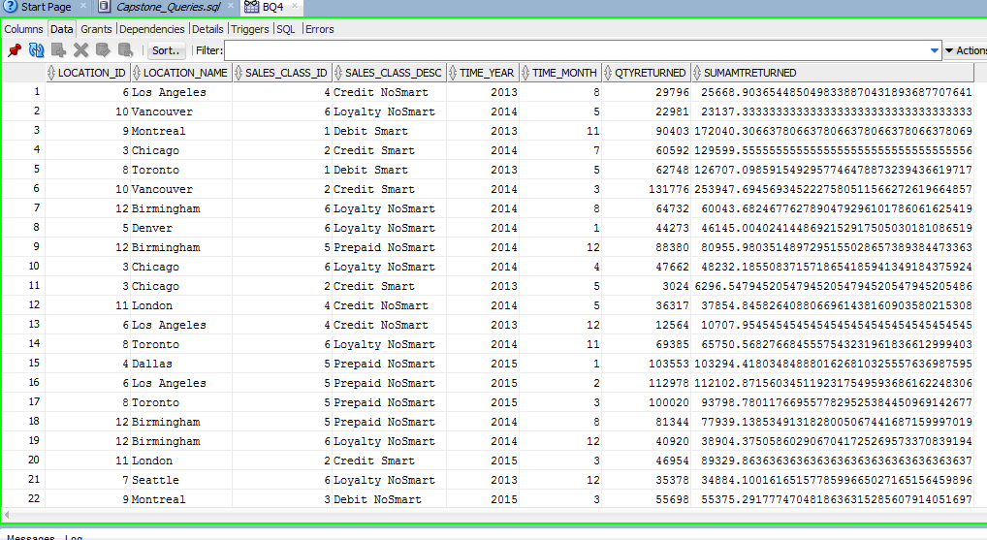

1. **BQ5**

SELECT

Job_id,Location_ID,Location_Name,Sales_class_id,sales_class_desc,

Date_Promised,Quantity_Ordered,LastShipDate,SUMSHIPQTY,

getBusDaysDiff(LastShipDate,Date_Promised) AS DaysDiff

FROM

(

SELECT W_JOB_F.Job_id,W_JOB_F.Location_ID,Location_Name,W_JOB_F.Sales_class_id,sales_class_desc,

Date_Promised,Quantity_Ordered,MAX(Actual_Ship_Date) AS LastShipDate,SUM(Actual_Quantity) AS SUMSHIPQTY

FROM W_JOB_F,W_LOCATION_D,W_SALES_CLASS_D,W_SUB_JOB_F,W_JOB_SHIPMENT_F

WHERE Actual_Ship_Date > Date_Promised

AND W_JOB_F.Location_id = W_LOCATION_D.Location_id AND W_Job_F.Sales_Class_Id = W_Sales_Class_D.Sales_Class_Id

AND W_SUB_JOB_F.SUB_JOB_ID = W_JOB_SHIPMENT_F.SUB_JOB_ID AND W_Job_F.Job_Id = W_SUB_JOB_F.JOB_ID

GROUP BY W_JOB_F.Job_id,W_JOB_F.Location_ID,Location_Name,W_JOB_F.Sales_class_id,sales_class_desc,

Date_Promised,Quantity_Ordered

)

WHERE LastShipDate > Date_Promised;

CREATE VIEW BQ5 AS

SELECT

Job_id,Location_ID,Location_Name,Sales_class_id,sales_class_desc,

Date_Promised,Quantity_Ordered,LastShipDate,SUMSHIPQTY,

getBusDaysDiff(LastShipDate,Date_Promised) AS DaysDiff

FROM

(

SELECT W_JOB_F.Job_id,W_JOB_F.Location_ID,Location_Name,W_JOB_F.Sales_class_id,sales_class_desc,

Date_Promised,Quantity_Ordered,MAX(Actual_Ship_Date) AS LastShipDate,SUM(Actual_Quantity) AS SUMSHIPQTY

FROM W_JOB_F,W_LOCATION_D,W_SALES_CLASS_D,W_SUB_JOB_F,W_JOB_SHIPMENT_F

WHERE Actual_Ship_Date > Date_Promised

AND W_JOB_F.Location_id = W_LOCATION_D.Location_id AND W_Job_F.Sales_Class_Id = W_Sales_Class_D.Sales_Class_Id

AND W_SUB_JOB_F.SUB_JOB_ID = W_JOB_SHIPMENT_F.SUB_JOB_ID AND W_Job_F.Job_Id = W_SUB_JOB_F.JOB_ID

GROUP BY W_JOB_F.Job_id,W_JOB_F.Location_ID,Location_Name,W_JOB_F.Sales_class_id,sales_class_desc,

Date_Promised,Quantity_Ordered

)

WHERE LastShipDate > Date_Promised;

(71 rows)

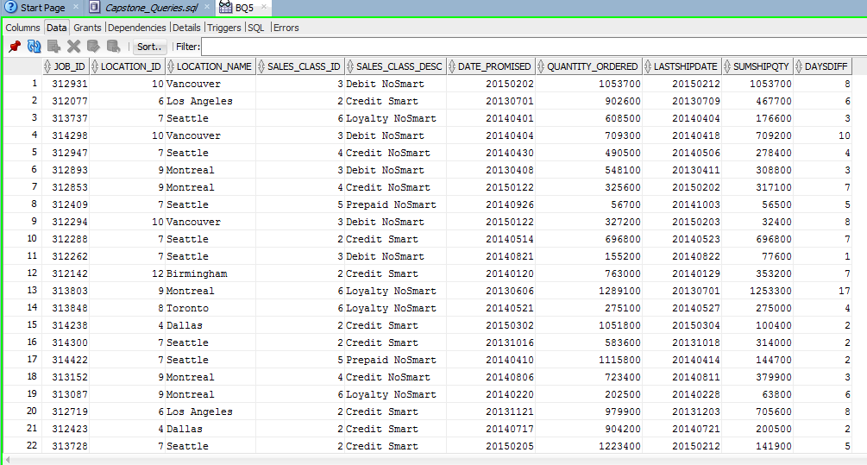

1. **BQ6**

SELECT

Job_id,Location_ID,Location_Name,Sales_class_id,sales_class_desc,

Date_Ship_By,FirstShipDate,getBusDaysDiff(FirstShipDate,Date_Ship_By) AS DaysDiff

FROM

(

SELECT W_JOB_F.Job_id,W_JOB_F.Location_ID,Location_Name,W_JOB_F.Sales_class_id,sales_class_desc,

Date_Ship_By,MIN(Actual_Ship_Date) AS FirstShipDate

FROM W_JOB_F,W_LOCATION_D,W_SALES_CLASS_D,W_SUB_JOB_F,W_JOB_SHIPMENT_F

WHERE W_JOB_F.Location_id = W_LOCATION_D.Location_id AND W_Job_F.Sales_Class_Id = W_Sales_Class_D.Sales_Class_Id

AND W_SUB_JOB_F.SUB_JOB_ID = W_JOB_SHIPMENT_F.SUB_JOB_ID AND W_Job_F.Job_Id = W_SUB_JOB_F.JOB_ID

GROUP BY W_JOB_F.Job_id,W_JOB_F.Location_ID,Location_Name,W_JOB_F.Sales_class_id,sales_class_desc,

Date_Ship_By

)

WHERE FirstShipDate > Date_Ship_By;

**CREATE VIEW BQ6** AS

SELECT

Job_id,Location_ID,Location_Name,Sales_class_id,sales_class_desc,

Date_Ship_By,FirstShipDate,getBusDaysDiff(FirstShipDate,Date_Ship_By) AS DaysDiff

FROM

(

SELECT W_JOB_F.Job_id,W_JOB_F.Location_ID,Location_Name,W_JOB_F.Sales_class_id,sales_class_desc,

Date_Ship_By,MIN(Actual_Ship_Date) AS FirstShipDate

FROM W_JOB_F,W_LOCATION_D,W_SALES_CLASS_D,W_SUB_JOB_F,W_JOB_SHIPMENT_F

WHERE W_JOB_F.Location_id = W_LOCATION_D.Location_id AND W_Job_F.Sales_Class_Id = W_Sales_Class_D.Sales_Class_Id

AND W_SUB_JOB_F.SUB_JOB_ID = W_JOB_SHIPMENT_F.SUB_JOB_ID AND W_Job_F.Job_Id = W_SUB_JOB_F.JOB_ID

GROUP BY W_JOB_F.Job_id,W_JOB_F.Location_ID,Location_Name,W_JOB_F.Sales_class_id,sales_class_desc,

Date_Ship_By

)

WHERE FirstShipDate > Date_Ship_By; (87 rows)

